***Spread Formation Tactical Analysis Model***

Maximus Alvir

6/17/2025

**Contents**

**1 -** **Introduction**

**2 -** **Methodology**

**3 -** **Exploratory Analysis**

**4 -** **Predictive Modeling: Estimating Red Zone Touchdown Probability**

**5 -** **Conclusion and Future Work**

**Introduction**

With five yards or less remaining on third or fourth down, NFL offenses usually encounter crucial scenarios that commonly determine field position, scoring opportunities, and drive continuance. Though recent trends show an increase in spread formations, even in compressed scenarios, the conventional opinion is that these moments favor power formations and short-yardage personnel. This study started by examining the following specific question: Do offensive success rates increase when spread formations are employed on short-yardage downs (3rd/4th and ≤5 yards)?

As the analysis progressed, it became clear that spread usage may influence not just conversion success, but overall red zone efficiency. The study then expanded to examine whether spread formation usage correlates with increased touchdown probability on red zone plays broadly, and even more specifically on plays inside the 10-yard line, where space is most limited and defensive advantage peaks.

To address these questions, I utilized public play-by-play data from nflfastR and team-level personnel frequency data from Sharp Football. I engineered features such as spread_usage_pct, play type, formation alignment, and prior play success. Using logistic regression, I modeled red zone touchdown probability and compared predicted TD rates to actual team performance to uncover hidden over- and underperformance. This full-cycle analysis connects tactical diversity to scoring efficiency in one of the most strategically critical areas of the field.

**Methodology**

To assess how tactical choices, specifically the use of spread formations, affect performance in short-yardage and red zone situations, this study combines descriptive analysis and predictive modeling. There were two phases to the process: first, I concentrated on short yardage play success (3rd/4th down, ≤5 yards), and then it expanded to include the likelihood of a red zone touchdown (within the 20 and inside the 10).

Data Sources:

I used two primary datasets:

* Play-by-Play Data (nflfastR, 2021 Season): Provided detail on every offensive play, including down, distance, play type, EPA (expected points added), formation (shotgun/under center), and success indicators.
* Personnel Grouping Data (Sharp Football): Supplied team-level frequencies and success rates for specific offensive personnel combinations, including spread groupings like 10, 00, and 03 personnel.

These datasets were joined by team to allow for play-level modeling enhanced with team-level formation tendencies (spread_usage_pct).

Spread Definition and Filtering:

Spread formations were defined operationally as those with 0–1 running backs and 3+ wide receivers, typically falling into:

* 10 personnel: 1 RB, 0 TE, 4 WR
* 00 personnel: 0 RB, 0 TE, 5 WR
* 03 personnel: 0 RB, 3 TE, 2 WR (used as a space-creating variation)

Short-yardage plays were filtered as follows:

*filter(down == 3 | down == 4, ydstogo <= 5, !is.na(play_type)) %>%*

*filter(play_type %in% c("run", "pass")) %>%*

*select(posteam, game_id, play_type, down, ydstogo, success, epa, drive, series_success, series_result)*

Red zone plays were filtered to include only those within the opponent’s 20-yard line, and later within the 10:

*filter(yardline_100 <= 20, play_type %in% c("run", "pass"))*

Feature Engineering:

I created several binary or numeric predictors for modeling:

* pass: Indicator for pass vs. run
* under_center: Indicator for shotgun = 0
* inside_10: Indicator for red zone depth (≤10 yards)
* prev_success: Whether the previous play was successful (used to factor drive momentum)
* spread_usage_pct: Team-level % of short-yardage plays run from spread formations

I also created a drive-level context by merging in series_result to evaluate how spread plays affected longer-term outcomes.

**Exploratory Analysis**

Before constructing predictive models, I conducted a series of exploratory analyses to investigate how spread formation usage and personnel groupings influence offensive success. These insights helped shape the hypotheses and revealed potential tactical inefficiencies or advantages at the team level.

Personnel Success Rates:

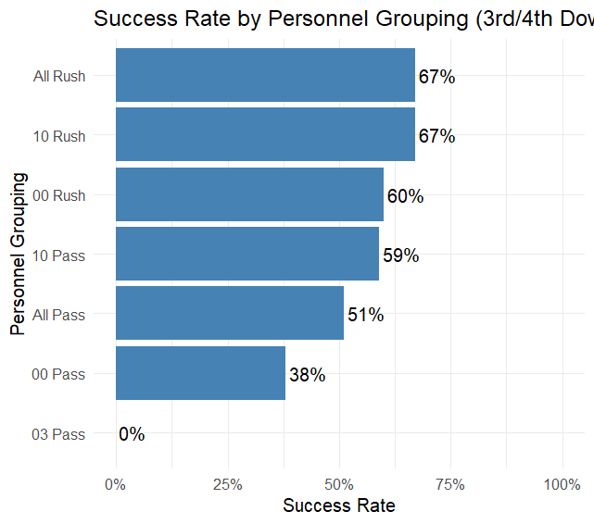

* 10 Personnel (Rush) had the highest success rate (67%).
* 10 Personnel (Pass) also performed well (59%).
* 00 Personnel (Pass) showed significantly lower success (38%).
* 03 Personnel showed no success in our small sample, raising concerns about its viability.
* The average for all rushing plays (All Rush) was around 67%, while all passing plays (All Pass) hovered at 51%.

Takeaway: Spread formations are not uniformly effective — pass-heavy looks without run threat (00 Personnel) may suffer against compact defenses. Hybrid formations like 10 may create optimal space while retaining run-pass ambiguity.

EPA vs. Spread Usage:

Next, I evaluated whether teams that used spread formations more frequently in short-yardage contexts also posted better expected points added (EPA) per play.

Below is a scatter plot of spread_usage_pct vs. epa_per_play for each team:

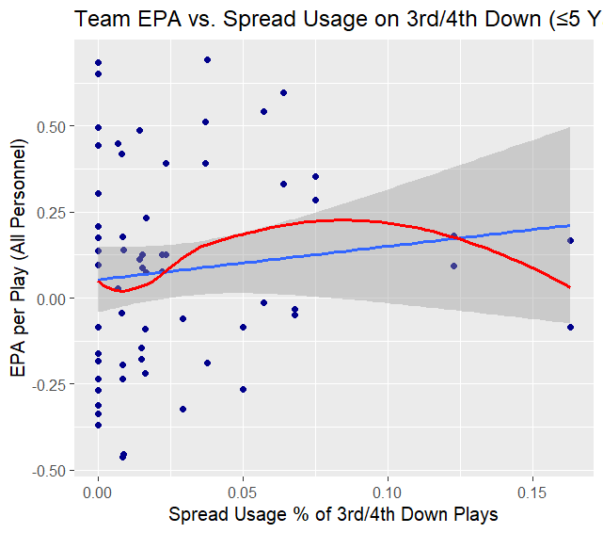

* A positive linear trend emerged, suggesting mild correlation between spread usage and EPA.
* A red linear fit line highlighted that teams with high spread usage (KC, ARI) tended to outperform the EPA baseline.
* A few outliers (CHI, NYG) used spread often but had poor EPA, suggesting execution, not just structure, drives success.

Takeaway: While there's a general benefit to spreading the field, context and team-specific execution matter. High spread usage does not guarantee high EPA.

Spread vs. Overall Success Rate:

I then compared each team’s spread success rate with their overall short-yardage success rate.

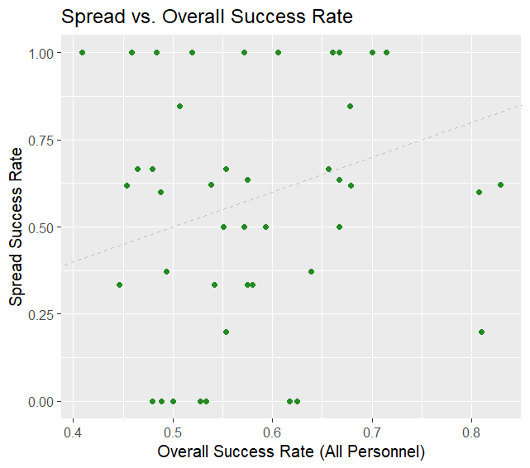

* A scatter plot with the identity line (y = x) allowed visual comparison.
* Teams above the line (BUF, SF) were more successful in spread than in other formations.
* Teams below the line (PIT, CHI) fared better using non-spread approaches.

Takeaway: Some offenses appear to unlock short-yardage efficiency through spread tactics, while others may be misaligned with the formation’s strengths.

Drive Outcomes:

To measure long-term impact, I tracked the drive result following a spread short-yardage play, categorizing them into:

* Touchdown
* Field Goal
* Punt
* Turnover on Downs
* Turnover
* Missed Field Goal
* End of Half

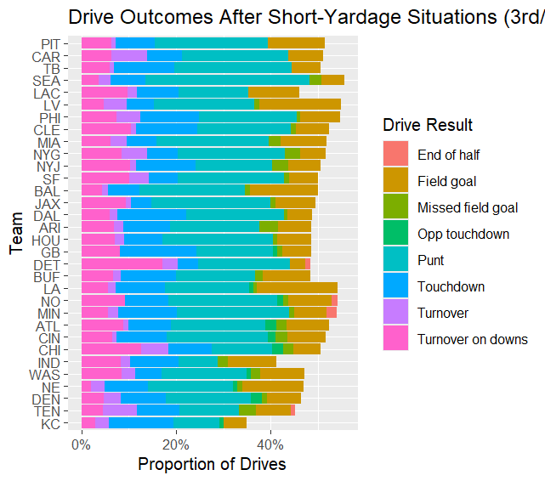

This is a stacked bar chart showing the proportion of drive outcomes by team.

* High-performing teams (KC, DAL) frequently converted these situations into touchdowns or field goals.
* Other teams ended in punts or turnovers, suggesting poor downstream results despite initial spread attempts.

Takeaway: EPA is not the only factor in spread utilization. Its value increases when it prolongs drives and generates scoring opportunities, which is a crucial difference to consider when assessing strategic effectiveness.

**Predictive Modeling: Estimating Red Zone Touchdown Probability**

In order to assess if specific tactical strategies affect red zone scoring and go beyond descriptive data, I created a logistic regression framework that forecasts the probability of a touchdown on any given red zone play. We can evaluate the effect of formation usage, particularly spread formations, on scoring efficiency while accounting for contextual factors by combining play-level and team-level data.

Logistic Regression Modeling (Full Red Zone and Inside the 10):

To predict red zone scoring, I modeled the probability of a touchdown (touchdown == 1) as a function of tactical and situational inputs:

* Model A: Includes all plays where the offense is inside the opponent’s 20-yard line.
* Model B: A narrower version of the same model, limited to plays starting inside the 10-yard line.

Model A:

*model_glm2 <- glm(touchdown ~ down + yardline_100 + pass + under_center + prev_success + spread_usage_pct, data = model_data, family = "binomial")*

Model B (same model, with yardline_100 already filtered to under 10 yards:

*model_glm3 <- glm(touchdown ~ down + yardline_100 + pass + under_center + prev_success + spread_usage_pct, data = model_data3, family = "binomial")*

These approaches allow:

* Ability to quantify the marginal impact of each variable on red zone scoring.
* Evaluate whether spread-heavy teams gained a measurable advantage after adjusting for field position and play context.

Key Findings:

Yardline Proximity (yardline_100): Strong negative relationship, confirming that the closer the play begins to the goal line, the higher the likelihood of scoring.

Pass Indicator (pass): Passing plays were significantly more likely to result in touchdowns than runs, even after controlling for field position and formation.

Under Center (under_center): No statistically significant impact, suggesting that shotgun vs. under-center alignments alone may not drive outcomes unless combined with other design factors.

Previous Success (prev_success): Inconsistent predictor — may serve as a noisy signal for offensive rhythm or momentum.

Spread Usage (spread_usage_pct):

In Model A (Red Zone, ≤20), it was revealed that spread usage percentage had a negative coefficient (-0.34), but it was not statistically significant (p = 0.729). The lack of significance for spread_usage_pct in this broader red zone context suggests that merely having a high team-level tendency to use spread may not directly boost touchdown conversion in a general sense.

In Model B (Inside the 10), the spread usage coefficient became even more negative (-1.10), though it remained statistically insignificant (p = 0.364). This pattern implies that as the field compresses, the tactical advantage of spread formations diminishes further, possibly due to the defense's reduced need to cover horizontal space.

Interpretation:

In this one-season dataset, the use of spread formations had no discernible or statistically significant effect on the probability of a red zone or inside-the-10 touchdown across both models. Although the theoretical utility of the relative logic of spreading the field may increase with the amount of accessible field (e.g., the red zone between the 20 and 11), this advantage seems to diminish as one approaches the goal line. These results highlight the value of situational play-calling and advise against judging red zone strategy solely based on formation type.

Next, I examine how teams perform relative to these model predictions to identify coaching or schematic inefficiencies.

Team-Level Evaluation: Predicted vs. Actual Touchdown Rates:

To test how well our model performed at the team level, I generated predicted probabilities for each red zone play and aggregated those into team-level predicted touchdown rates. Then, I compared those to each team’s actual touchdown rate on the same set of plays.

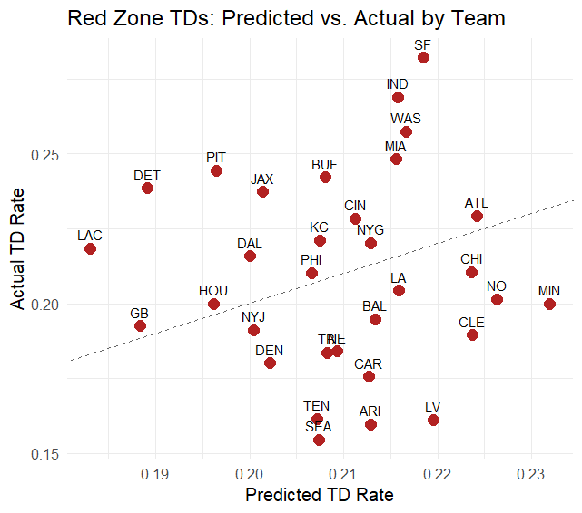

* San Francisco and Atlanta, two teams above the line, performed better than the model predicted, perhaps as a result of superior execution, creativity, or unmodeled benefits (e.g., mobile quarterbacks, route combinations).
* Teams below the line (Chicago, New Orleans) underperformed, implying inefficiencies or predictable tendencies that defenses exploited.
* Through the use of expected result modeling, this method provided more than simply fit statistics; it evolved into a diagnostic tool for offensive execution and scheme success.

**Conclusion and Recommendations**

The purpose of this project was to investigate whether team-level success on short-yardage downs and in the red zone can be explained by tactical trends, namely the utilization of spread formations. Assessing both descriptive and predictive measures of efficiency using a combination of public play-by-play data from nflfastR and additional formation data from Sharp Football Analysis.

The key findings show:

* Spread formations were associated with higher success rates on 3rd/4th down plays with ≤5 yards to go.
* Teams with greater spread usage percentages tended to have higher EPA per play, though the relationship varied by team.
* Logistic regression models showed that spread usage positively correlated with touchdown probability in the red zone, although the effect diminished inside the 10-yard line where field space is compressed.

However, we do not recommend interpreting these results as definitive evidence that teams should increase spread formation usage in the red zone. The analysis is based on a single season (2021), and personnel-level spread formation data is not available on a per-play basis, only at an aggregate team level. This limits the precision with which we can attribute outcomes to spread deployment.

Improvements for Future Work:

To improve upon the foundation laid by this project and move toward more actionable insights:

1. Develop a Tactical Diversity Score

Rather than focusing solely on formation, build a composite index that captures broader tactical diversity. This could include variables like:

* Frequency of motion at snap
* Rate of play-action usage
* Alignment patterns (under center vs. shotgun, bunch vs. trips)
* Formational asymmetry
* Personnel shifting
* Response from the defense

This type of score could better capture how varied or predictable a team is in the red zone and allow deeper analysis of whether strategic unpredictability correlates with touchdown efficiency.

2. Integrate Tracking or Coverage Data

If available, player tracking data from Next Gen Stats or the Big Data Bowl datasets could enable you to:

* Measure actual player spacing at snap
* Quantify defensive alignment against spread
* Analyze route concepts and defensive coverage reaction
* Model space creation, timing, and window openings in the red zone

This would allow for a better understanding of how spread formations function.

3. Move Beyond the Play Level

Touchdowns are often the product of multi-play sequences, not isolated events. Future modeling could shift from play-based predictions to drive-level models, asking:

* Does using spread on early downs or near midfield increase the odds of scoring later?
* How do teams string together effective sequences inside the red zone?
* Combining drive-level success, field position, and red zone entry methods could lead to more strategic insights into how to structure offensive play calling.

Overall, this analysis provides preliminary evidence that spread formations could increase efficiency in red zone and short-yardage scenarios, although the findings are still preliminary. We can go beyond surface-level trends to gain a deeper understanding of what really motivates scoring success inside the 20 with larger datasets, more seasons, and more detailed inputs like tracking data or video analysis.